PURPOSE:
To establish criteria for mobile take away food vendors seeking permission to operate from a public road.
SCOPE:
Section 56C of the Vehicle and Traffic Act 1999 stipulates that food vendors cannot operate from a public road without a permit from the General Manager of the relevant council. This permit can be issued for a maximum of twelve months.
In assessing whether to grant a permit, the Act requires the General Manager to take into account traffic safety, public convenience and any other relevant issues.
POLICY:
Part A: Take away food vendors stationary for greater than 15 minutes
Council requires food vendors seeking permission to operate from a public road for a period of greater than 15 minutes to specify the particular locations that they propose to operate from.
Council will assess the suitability of each nominated site from a general road safety and convenience perspective, taking into account the surrounding activity and the nature of the vehicle being used by food vendors.
Council also requires proposed locations and operation from them to meet the following conditions.
- Prohibited areas and times
  - Mobile food vendors are not to operate on public roads within the central business district (CBD). Appendix 1 provides a map showing the area defined as the CBD.
  - Mobile food vendors are not to operate on identified major roads unless operating from a service road. For the purposes of this policy, a map showing the location of identified major roads is provided as Appendix 2.
  - Mobile food vendors are not to operate on public roads within 200m (measured by travel distance of a pedestrian) of a fixed take away food premises at the same time that the fixed take away food premises is operating unless the fixed take away food premises has clearly expressed in writing a tolerance for mobile food vendors operating closer and/or concurrently.
  - Mobile food vendors are not to operate on public roads within 100m (measured by travel distance of a pedestrian) of a residential dwelling between the hours of 10pm and 7am.
- Minimum footpath width
Mobile food vendors must operate adjacent to footpaths with a width of at least 1500mm. Mobile food vendors must not operate adjacent to nature strips or other soft or pervious surfaces.
- Vendors must not leave vehicles unattended
Mobile food vendors must not leave the vehicle from which they conduct their business parked unattended on a public road at a location specified on their permit for a period longer than one hour.
- Refuse Bins
Mobile food vendors must place out for use, while trading to the public, a bin to accept refuse adjacent to the serving hatch. The bin must be a minimum 50 litres and all rubbish deposited removed by the food vendor and disposed responsibly.
- Permits are not transferable
Permits granted to mobile food vendors to operate from a public road are only for the business identified in the permit and are not transferable.
- Permits are for one vehicle
Permits granted to mobile food vendors to operate from a public road are for one vehicle only. A business seeking to operate from more than one vehicle must apply for a separate permit for each vehicle. A non-motorised van/trailer coupled with a vehicle solely used to tow will be defined as one vehicle.
- Duration of permit
Permits granted to mobile food vendors to operate from a public road will be issued for twelve months for the period 1 January - 31 December. A business seeking to amend the particular locations that they operate from must apply for a new permit. Amendments will not be made to live permits with respect to the locations specified.
- Charges for permit
An annual fee will be levied for the permits issued to food vendors to operate from a public road. Refunds will not be provided for any cancelled, inactive or superseded permit. Permits issues throughout the year will be charged a fee equal in units of a quarter with the current quarter applying in full.
This fee will be established using the charge applied by Council for on street dining in District Centres as set out in the annual fees and charges. This charge will be applied to the notional area occupied and used by mobile food vendors operating on public roads, equal to 24 square metres. This is taken to be the average length of a parking bay (6000mm) multiplied by the minimum footpath width required adjacent to the serving hatch (1500mm) plus parking space occupied (2500mm).
- Exemptions
This policy does not apply to applications by food vendors to operate from a public road as part of a Council supported or endorsed event on a public road.
This policy only applies to urban areas of the municipality.
Part B: Take away food vendors stationary for less than 15 minutes
Mobile food vendors operating from a particular location for less than 15 minutes are permitted by Council to operate from a public road so long as they comply with the conditions set out in Part A (1) and (2) of this policy.
Nevertheless, this permission may be revoked by the General Manager if it is considered that public safety is at risk.
Part C: Other matters
Any permit granted to mobile food vendors to operate in a public road does not guarantee availability or exclusivity of a particular location.
Although not governed by this policy, all mobile food vendors operating from a public road are to ensure:
  - they are legally parked at all times;
  - they hold a valid certificate of registration for businesses selling food from a vehicle; and
  - they have approval to erect any signs or furniture associated with their business.
PRINCIPLES:
The Council's Organisational Values apply to all activities.
RELATED POLICIES & PROCEDURES:
On Street Dining: Guidelines & Specifications (18-HLPrx-002)
RELATED LEGISLATION:
Vehicle and Traffic Act 1999
REFERENCES:
N/A
DEFINITIONS:
Take away food premises: the use of land to prepare and sell food and drink primarily for immediate consumption off the premises (as defined in the Launceston Interim Planning Scheme 2012).
REVIEW:
This policy will be reviewed every 5 years or more frequently, if dictated by operational demands and with Council’s approval.

APPENDIX 1: Launceston CBD
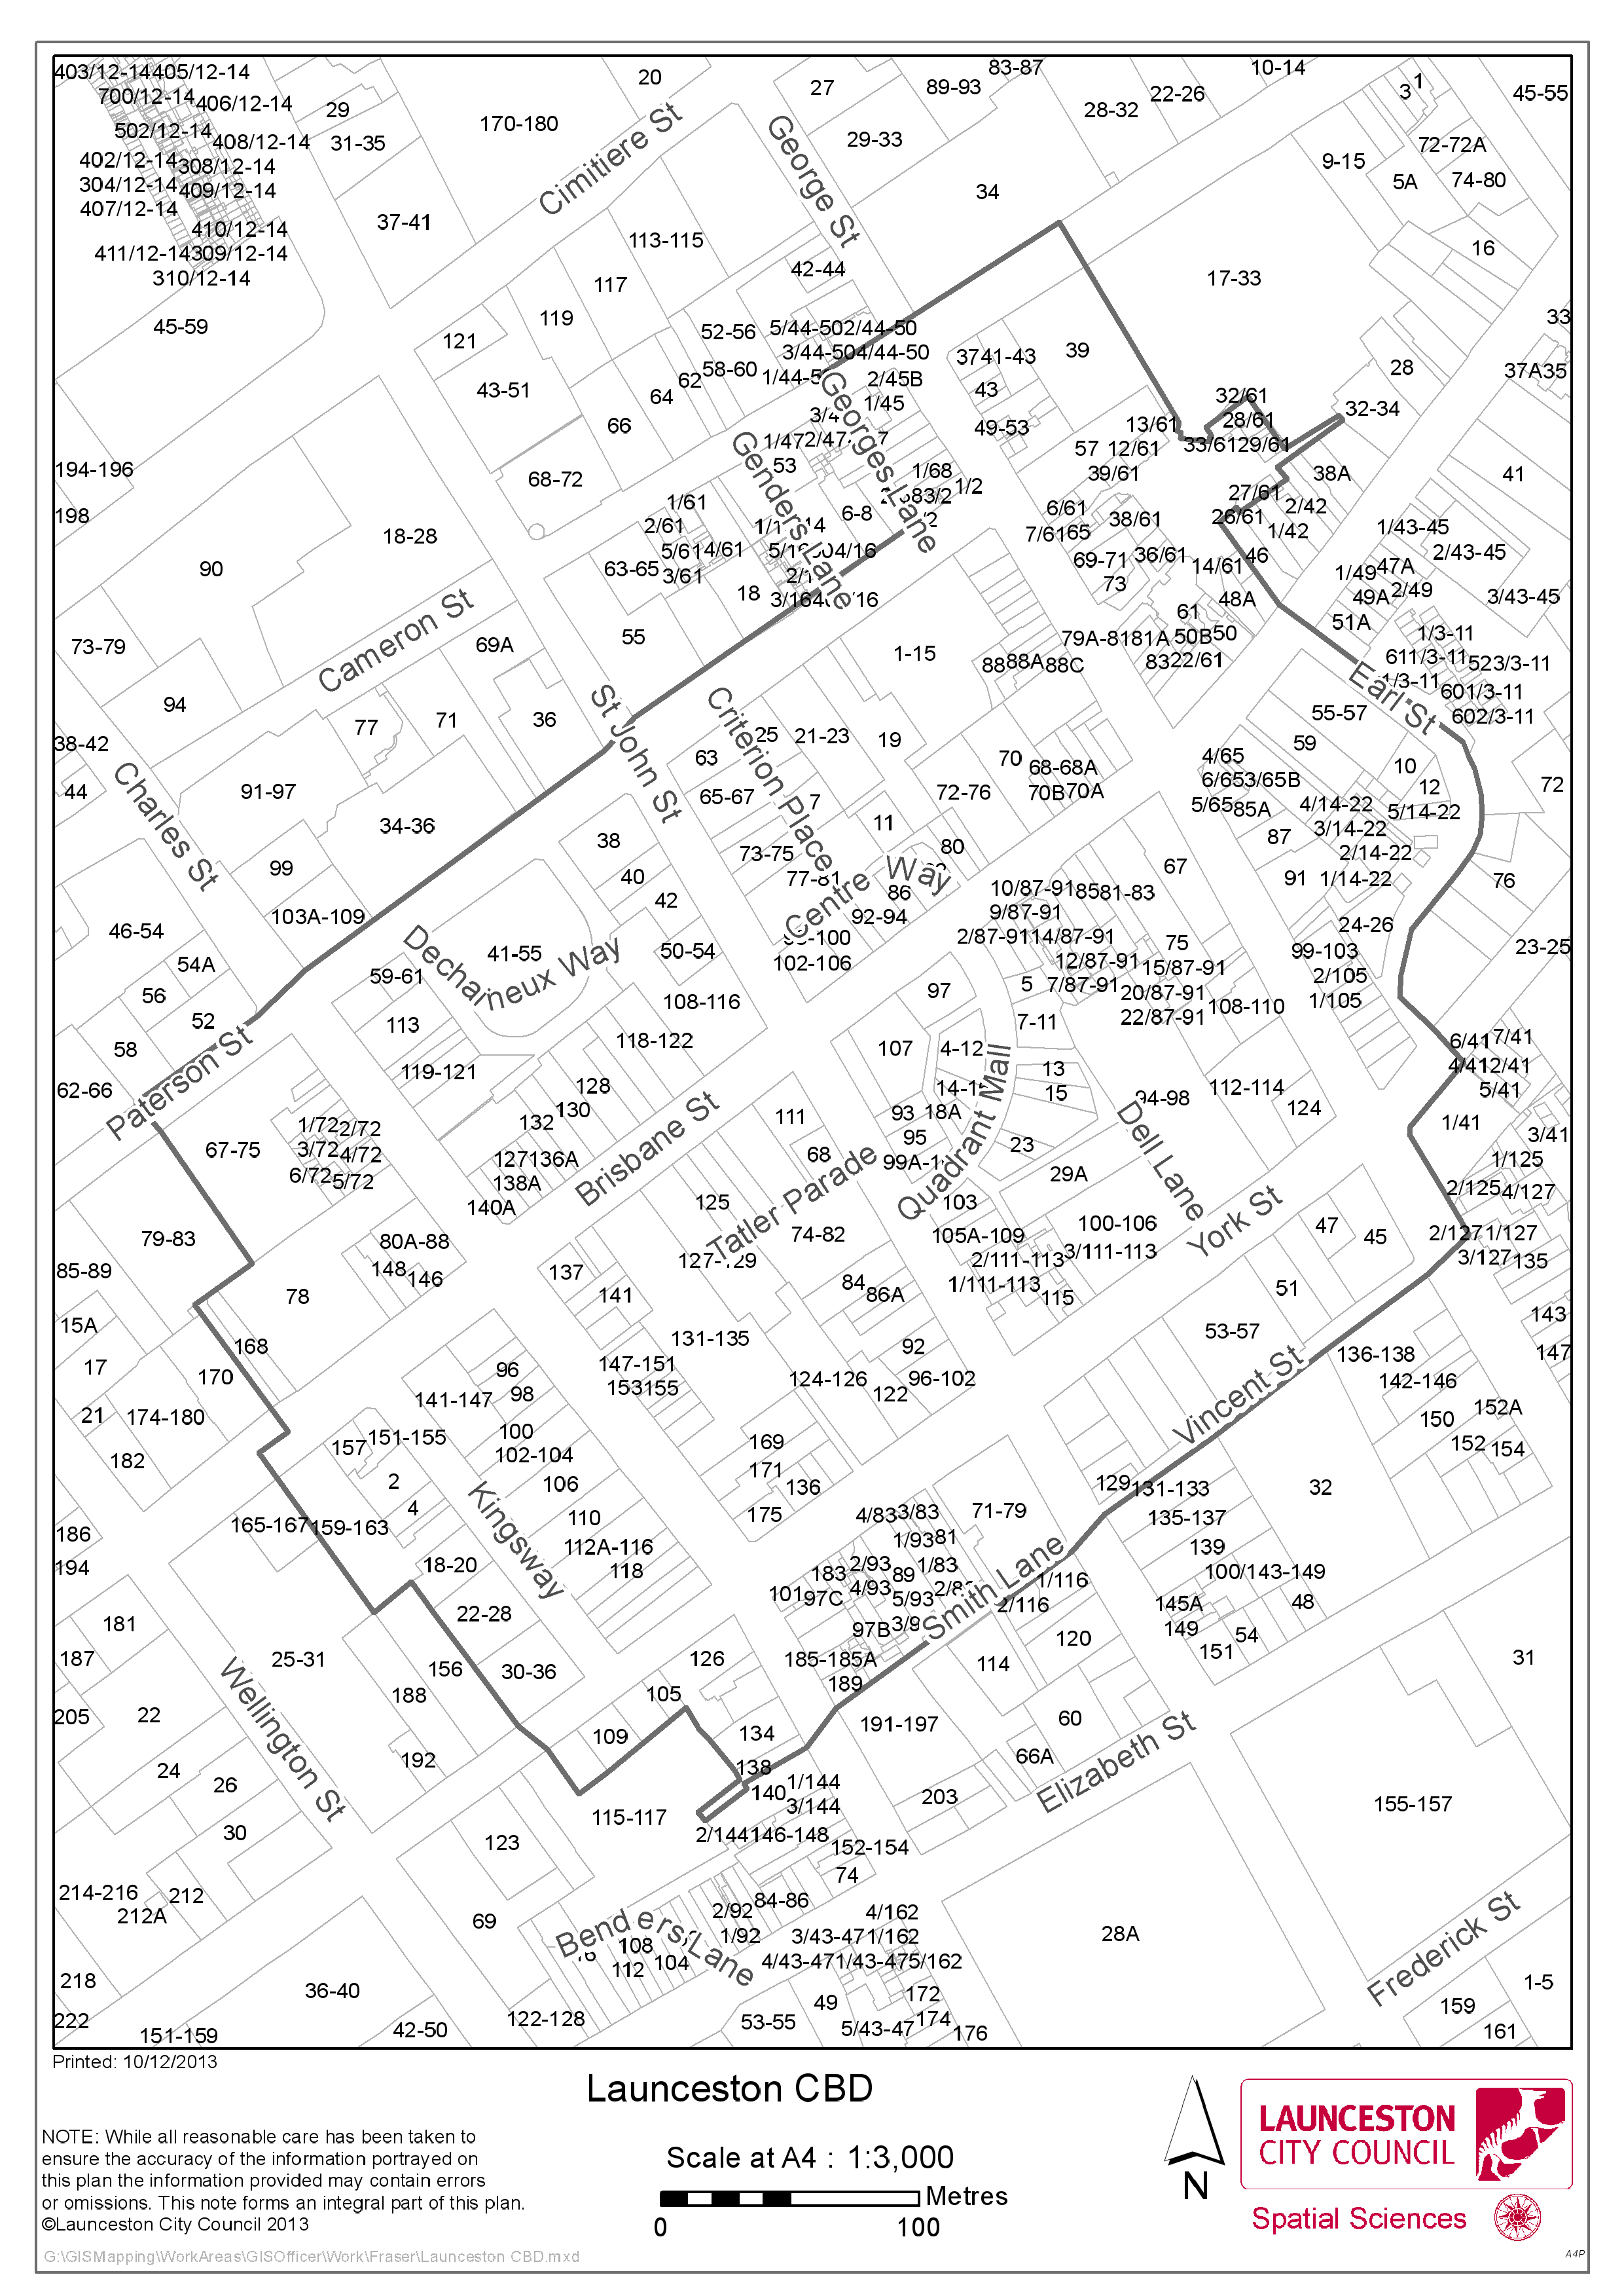

APPENDIX 2: Major roads prohibited for mobile food vendors
