TITLE: Restricted Areas Under the Dog Control Act 2000 (Tas)

FILE NO: SF0079

AUTHOR: Peter Denholm (Team Leader Regulations Services)

ACTING GENERAL MANAGER: Richard Jamieson (Community and Place Network)

DECISION STATEMENT:
To consider the declaration of restricted areas for the purposes of the Dog Control Act 2000 (Tas).

PREVIOUS COUNCIL CONSIDERATION:
Council - 10 July 2017 - Agenda Item 15.1 - Dog Management Policy Review

RECOMMENDATION:
That Council:

1. forms the view that the following areas should be restricted areas for the purpose of the Dog Control Act 2000 (Tas):
a. Riverbend Park, marked in red on the map appearing at Recommendation 4(a) is a restricted area where dogs, other than guide dogs or hearing dogs, are restricted from entering at all times.
b. part of the Heritage Forest off-leash area, marked in blue on the map appearing at Recommendation 4(b), is a restricted area, a condition of use of which is that greyhounds are the only dogs permitted in the area.
c. part of the Heritage Forest off-leash area, marked in red on the map appearing at Recommendation 4(b), is a restricted area, a condition of use of which is that vulnerable dogs are the only dogs permitted in the area.

2. requests the Chief Executive Officer to exercise Council's powers under sections 7 and 24 of the Dog Control Act 2000 (Tas), to allow consultation with relevant bodies and organisations and to arrange for public notice of and the opportunity for the public to make submissions on the intended declaration and consequent necessary amendments to the Council's Dog Management Policy.

3 notes that following consultation with relevant bodies and organisations and consideration of any submissions from the public in respect of the intended changes, a further item will come back to Council for determination.

4. note the maps referred to at Recommendation 3. are as follows:
a. Riverbend Park.

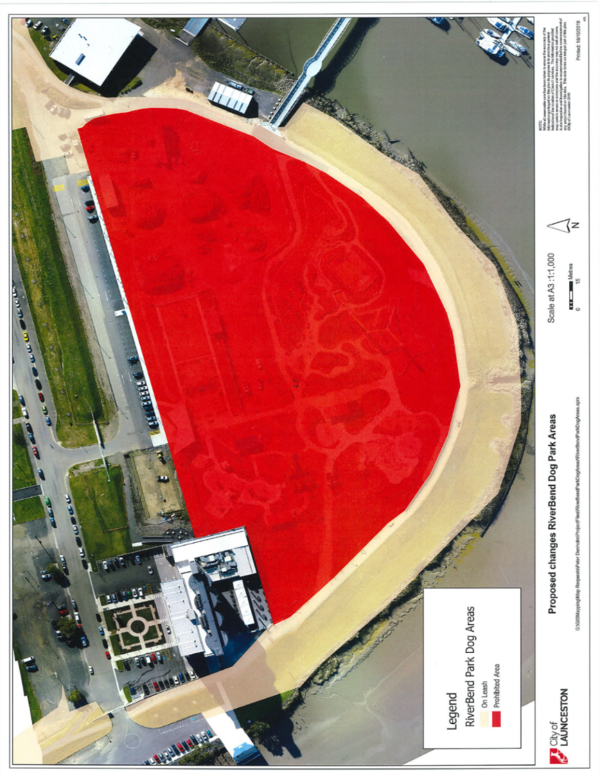

b. Heritage Forest off-leash area.

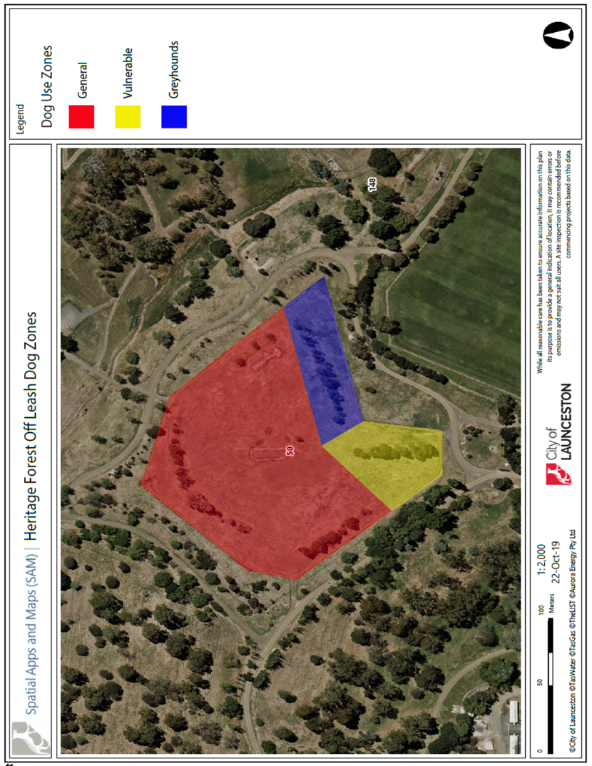

Mrs L Hurst (General Manager Community and Place Network) and Mr P Denholm (Team Leader Regulations Services) were in attendance to answer questions of Council in respect of this Agenda Item.

DECISION: 6 February 2020

MOTION

Moved Councillor A E Dawkins, seconded Councillor R I Soward.

That the Motion, as per the Recommendation to Council, be adopted.

CARRIED 12:0

FOR VOTE: Mayor Councillor A M van Zetten, Deputy Mayor Councillor D C Gibson, Councillor J Finlay, Councillor A E Dawkins, Councillor N D Daking, Councillor D H McKenzie, Councillor K P Stojansek, Councillor R I Soward, Councillor P S Spencer, Councillor J G Cox, Councillor A G Harris and Councillor T G Walker

